“Antimicrobial resistance, bacterial density, and eradication outcomes of Helicobacter pylori infection in Egyptian patients: a prospective cohort study”
Abstract
Background: Helicobacter pylori is a widespread pathogen linked to gastritis, peptic ulcers, and gastric cancer. Increasing antimicrobial resistance is making eradication more difficult. .
Aim: To study how clinical symptoms, endoscopic and histopathological findings, bacterial density, and antimicrobial resistance patterns of H. pylori are related in Egyptian patients. .
Methods: In our study, 100 treatment-naïve patients with gastrointestinal symptoms suggestive of H. pylori infection and positive stool antigen tests underwent endoscopy, gastric biopsy, histopathology, and culture with antimicrobial susceptibility testing. All patients received 14-day levofloxacin-based triple therapy. Treatment response was assessed clinically and by stool antigen testing. .
Results: Epigastric pain was the most common symptom, reported by 83% of patients, followed by nausea and vomiting in 58%. Weight loss and pallor were less frequent, at 24% and 18%, respectively. Abnormal upper gastrointestinal endoscopy findings were present in 97% of patients, with 53% showing erosive or ulcerative lesions, indicating significant mucosal involvement. Higher H. pylori bacterial density was associated with gastric ulcers, erosions, mucosal atrophy, and duodenal lesions (p<0.001). Higher bacterial density was significantly associated with severe mucosal lesions and increased the risk of ulcerative disease, resulting in more severe epigastric pain and gastrointestinal bleeding. Histopathology revealed chronic inflammation in 95% of patients and active inflammation in 80%, indicating ongoing mucosal activity. Treatment failed in 43% of cases and was closely associated with higher bacterial density, confirming the impact of bacterial load on treatment outcomes. Antimicrobial testing showed high resistance to common first-line drugs, including amoxicillin (53.5%), clarithromycin (46.5%), and amoxicillin–clavulanic acid (50.7%). In contrast, meropenem, doxycycline, and rifampicin showed no detected resistance, indicating potential utility against infections with resistance.
Conclusion: Bacterial density is an important predictor of mucosal damage and treatment failure. The high rate of resistance to standard first-line antibiotics highlights the need for new treatment strategies and region-specific guidelines.
Keywords: Helicobacter pylori, antibiotic resistance, bacterial density, gastric ulcers, treatment outcomes.

Abbreviations:
Ag: Antigen; Amox-Clav: Amoxicillin-clavulanic acid; AST: Antimicrobial Susceptibility Testing; C-index: Harrell’s Concordance Index; CLSI: Clinical and Laboratory Standards Institute; CLR: Clarithromycin; EUGDD: Erosive and Ulcerative Gastroduodenal Disease; H. pylori: Helicobacter pylori; Hb: Haemoglobin; N: Total number of patients; NSAIDs: Non-Steroidal Anti-Inflammatory Drugs; OD: Optical Density; PPI: Proton Pump Inhibitor; SD: Standard Deviation; SPSS: Statistical Package for the Social Sciences.

Introduction

Helicobacter pylori is a highly prevalent Gram-negative bacterium that colonizes the gastric mucosa in more than half of the global population. Infection prevalence varies considerably by geographic region and socioeconomic status, with higher rates in developing countries compared to industrialized nations (1,2). Reported prevalence ranges from 54.7% to 79.1% in Asia and Africa, 37.1% to 63.4% in North and South America, and approximately 47% in Europe (3). In Egypt, infection rates remain particularly high, with reported prevalence ranging from 13% to 90.9%, depending on age group, study population, and diagnostic methods. The estimated overall prevalence is approximately 62.5%, reaching nearly 67% among adults (4).
H. pylori infection is a well-established cause of chronic gastritis and peptic ulcer disease. It is also a major risk factor for gastric adenocarcinoma and mucosa-associated lymphoid tissue (MALT) lymphoma. In addition to gastrointestinal manifestations, growing evidence links H. pylori infection to a range of extraintestinal disorders, including those affecting the hematologic, cardiovascular, metabolic, neurologic, and dermatologic systems (5). Chronic H. pylori gastritis is histologically characterized by persistent inflammatory infiltrates, lymphoid follicle formation, and neutrophilic activity within the gastric mucosa (6,7).
Upper gastrointestinal endoscopy with gastric biopsy is the preferred diagnostic approach for symptomatic patients because it allows direct visualization of mucosal abnormalities, histopathological assessment, and microbiological evaluation. Endoscopic biopsy also enables early detection of premalignant gastric lesions, which is critical for gastric cancer prevention strategies (8). However, the relationships among bacterial density, endoscopic severity, histopathological findings, and therapeutic outcomes remain incompletely understood, particularly in high-prevalence populations.
The increasing global prevalence of antimicrobial resistance among H. pylori strains presents a major challenge to effective eradication therapy. Resistance to commonly used antibiotics, particularly clarithromycin, metronidazole, and fluoroquinolones, has substantially reduced eradication success rates worldwide. An Egyptian single-center study reported high rates of resistance to metronidazole, amoxicillin, and rifampicin, with lower rates of resistance to doxycycline, moxifloxacin, and levofloxacin (9). However, limited data exist regarding the relationships among antimicrobial resistance patterns, bacterial density, disease severity, and eradication outcomes in Egyptian patients.

While previous Egyptian studies have primarily examined antimicrobial resistance patterns or eradication outcomes in isolation, this prospective study offers a comprehensive evaluation by integrating antimicrobial susceptibility testing, bacterial density, histopathological findings, and eradication outcomes within a single cohort of treatment-naïve adult Egyptian patients. In contrast to earlier local reports, this study also investigates the association between bacterial density and treatment failure and assesses antimicrobial resistance as an independent predictor of eradication failure. The findings provide current local antimicrobial resistance data that may inform future empirical treatment strategies in Egypt.
Therefore, the present study aimed to evaluate the associations among H. pylori bacterial density, clinical manifestations, endoscopic and histopathological findings, antimicrobial resistance profiles, and treatment outcomes in Egyptian patients with H. pylori infection.

PATIENTS AND METHODS:
Study Design, Setting, and Approvals
This prospective, interventional cohort study was conducted between January 2023 and December 2024 at Al-Rajhi Liver University Hospital, Assiut University, Egypt. The study protocol was approved by Institutional Review Board (IRB) and the Research Ethics Committee of the Faculty of Medicine, Assiut University (Approval No: 17200751). The study adhered to the ethical principles of the Declaration of Helsinki (10) and was registered at ClinicalTrials.gov (NCT05444439). Written informed consent was obtained from all participants prior to enrollment.
Participant Selection and Power Calculation
One hundred treatment-naïve patients presenting with gastrointestinal symptoms suggestive of H. pylori infection, as confirmed by stool antigen testing, were enrolled. Stool antigen testing was selected over the urea breath test due to its lower cost and high sensitivity (96%) (11). Exclusion criteria comprised prior eradication therapy, recent antibiotic or proton pump inhibitor use, pregnancy, severe comorbidities, or lack of consent. All participants underwent a medical history review, physical examination, stool antigen testing, and upper endoscopy of the esophagus, stomach, and duodenum. Clinical, endoscopic, and histological findings were recorded, and gastric biopsies were cultured and assessed for antimicrobial sensitivity.
Sample size calculation:
The sample size was calculated using G power software version 3.1.3 with the following assuming: effect size 0.5, alpha error probability 0.05, power 0.80. The number of people needed for the study was worked out using a standard formula. In our study, based on regional data suggesting a levofloxacin resistance prevalence of approximately 6.7% (12), and accepting a margin of error of 10%, a minimum sample size of 97 patients was required. To account for potential dropouts and culture failure, we aimed to enroll 100 participants.
H. pylori Ag In stool
Fresh faecal samples were collected and stored at -70ºC for analysis. The SD H. pylori antigen ELISA kit was used to test for H. pylori antigen according to the manufacturer's instructions. Faecal samples were diluted, then controls and a peroxidase-coated monoclonal antibody were added. The mixture was incubated for 1 hour at 37ºC. After incubation, samples were washed to remove loose material. Substrate was then added, and the mixture was incubated for an additional 10 minutes. Results were read using a spectrophotometer set to 450 nm. If the optical density (OD) of the stool H. pylori antigen was less than or equal to the negative mean OD plus 0.1, the result was considered negative. A positive result was classified as highly positive if the OD was 3.0 or higher, and weakly positive if the OD was between the negative mean OD plus 0.1 and 3.0 (13). Eradication was confirmed using the H. pylori stool antigen test performed at least 4 weeks after completion of eradication therapy. Proton pump inhibitors were discontinued for at least 2 weeks before testing to minimize the risk of false-negative results, in accordance with current international guidelines.
Endoscopy
All patients underwent upper gastrointestinal endoscopy with the Olympus XQ40 system (Olympus Optical, Tokyo, Japan) under intravenous propofol anesthesia. Each patient fasted for at least 8 hours before the procedure. Endoscopic findings were systematically documented, and biopsy samples were obtained from both the antrum and corpus of the stomach. Specimens designated for histological examination were promptly preserved in 10% formalin, while those intended for culture and sensitivity testing were placed in saline.

Histopathological examination of gastric biopsies

A total of 100 formalin-fixed paraffin-embedded blocks were collected. From these, 200 tissue sections, each 3 micrometers thick, were prepared using a SLEE-MAINZ CUT4060 microtome. The sections were spread in a water bath and mounted on coated glass slides. All sections underwent deparaffinization in xylene and rehydration through decreasing concentrations of alcohol, followed by water. One hundred sections were stained with Giemsa and the remaining 100 with hematoxylin and eosin (H&E).
The Giemsa stain working solution (pH 6.8) was prepared by diluting 40 mL of the stock solution with 60 mL of distilled water. The stock solution consisted of 4 g of Giemsa powder mixed with 250 mL each of glycerol and methanol. An expert gastrointestinal pathologist examined the histological sections to standardize the classification of gastritis (14).
Biopsy samples demonstrated the characteristic morphology of H. pylori: curved, comma-shaped, or S-shaped bacilli measuring 2–4 µm in length and 0.5–1 µm in thickness, typically located along the surface of the mucus layer and within foveolar mucin. Gastritis was graded according to the updated Sydney system, which assesses glandular atrophy, chronic inflammation, neutrophil activity, intestinal metaplasia, and H. pylori density (15). Dysplasia and malignancy were also recorded.

Culture and Antimicrobial Susceptibility Testing (AST) by Agar Dilution:

Gastric biopsies were cultured on Columbia blood agar base supplemented with 5% defibrinated blood and H. pylori selective supplements under microaerophilic conditions (37°C). Isolates were identified by colony morphology and positive urease, oxidase, and catalase tests results.
Minimum inhibitory concentrations (MICs) of amoxicillin, amoxicillin–clavulanic acid, clarithromycin, metronidazole, gatifloxacin, ciprofloxacin, levofloxacin, tetracycline, nitazoxanide, imipenem, moxifloxacin, meropenem, doxycycline and rifampicin were determined using the agar-dilution method following CLSI M45 principles for Helicobacter pylori. Mueller–Hinton agar (Oxoid CM0337; Thermo Fisher Scientific, Basingstoke, UK) supplemented with 5% defibrinated sheep blood aged for at least 2 weeks (Oxoid SR0051; Thermo Fisher Scientific) was used.

Analytical-grade antimicrobial powders were obtained from Sigma-Aldrich, Merck KGaA (Darmstadt, Germany). Stock solutions were freshly prepared according to the manufacturer’s instructions and adjusted for powder potency. Serial twofold antimicrobial concentrations were incorporated into molten supplemented Mueller–Hinton agar cooled to approximately 45–50°C.
Fresh colonies from 72-h H. pylori cultures were suspended in sterile 0.85% saline and adjusted to a 2.0 McFarland standard. Approximately 1–3 µL of each suspension was inoculated onto the agar surface using a Steers replicator. Plates were incubated at 35 ± 2°C for 72 h in a humid microaerophilic atmosphere generated using CampyGen sachets (Oxoid, Thermo Fisher Scientific). The MIC was defined as the lowest antimicrobial concentration that completely inhibited visible growth compared with the antimicrobial-free control.
MICs for amoxicillin, clarithromycin, levofloxacin, tetracycline, metronidazole and rifampicin were interpreted according to EUCAST Clinical Breakpoint Tables, version 16.1[16]. MICs for the remaining agents were categorized using the prespecified literature-derived exploratory thresholds presented in Supplemental Table S1.

Empirical standard triple therapy:

Empirical standard triple therapy was initiated, consisting of levofloxacin 500 mg once daily, amoxicillin 1000 mg twice daily for 14 days, and pantoprazole 20 mg twice daily for 1 month. Clinical and laboratory responses were evaluated, and H. pylori eradication was confirmed using stool antigen tests conducted 2 weeks after proton pump inhibitor discontinuation and at least 4 weeks following completion of the 14-day antibiotic regimen, with rigorous adherence monitoring. The empirical levofloxacin-based triple regimen was chosen based on the most current regional antimicrobial susceptibility data available at the time of study design, which indicated a relatively low prevalence of levofloxacin resistance among Egyptian H. pylori isolates (6.7%) (12).

Statistical analysis
Collected data were coded, processed, and analyzed using SPSS (Statistical Package for the Social Sciences) version 20 for Windows (IBM SPSS Inc., Chicago, IL, USA). There were no missing data for any of the primary or secondary study variables. Continuous variables were expressed as mean ± standard deviation (SD), and normality was assessed using the Shapiro–Wilk test. Comparisons between continuous variables were performed using Student’s t-test. Categorical variables were expressed as frequencies and percentages and were compared using the chi-square test or Fisher’s exact test, as appropriate. A two-sided p-value <0.05 was considered statistically significant.
Multivariable logistic regression analysis was performed to identify independent predictors of successful Helicobacter pylori eradication. Successful eradication, defined as a negative stool antigen test after completion of therapy, was used as the dependent outcome variable. Candidate independent variables included age, body mass index (BMI), haemoglobin level, NSAID use, smoking status, and bacterial colonization density. Variables with a p-value <0.10 in the univariate analysis were entered into the multivariable logistic regression model. Model fit was assessed using the Hosmer–Lemeshow goodness-of-fit test. Adjusted odds ratios (ORs) with 95% confidence intervals (CIs) were calculated, and a two-sided p-value <0.05 was considered statistically significant.
Result
The patient cohort had a mean age of 35.9 years (standard deviation: 13.9 years). Males represented 65% of participants, females 35%, and 44% resided in urban areas. Most patients (84%) were non-smokers; 8% had diabetes mellitus, 5% had hypertension, 2% had liver disease (cirrhosis), 1% had ischaemic heart disease, 5% had thyroid disease, and 2% had chronic kidney disease. The most prevalent gastrointestinal symptoms were abdominal pain (83%) and vomiting or nausea (58%). Additional symptoms included hematemesis or melena (21%), anorexia (20%), and heartburn (19%). Symptom severity was classified as mild in 60 patients (60%), moderate in 30 (30%), and severe in 10 (10%) based on symptom frequency, intensity, impact on daily activities, and the presence of alarm symptoms. The most frequent extra-intestinal manifestations were weight loss (24%), pallor (18%), migraine (13%), and urticaria (12%) (Table 1).
Erosive and ulcerative gastroduodenal disease (EUGDD) was the most common endoscopic finding (53%), followed by gastric redness (34%) (Fig 2).
Chronic inflammation was present in 95% of biopsy specimens, with moderate inflammation observed in 49%. Neutrophilic activity was detected in 80% of samples, and intestinal metaplasia in 3% of patients. No biopsy specimen showed Grade III glandular atrophy, intestinal metaplasia, or severe H. pylori colonization (Fig 3).
Epigastric pain, hematemesis or melena, and weight loss were associated with higher bacterial burden. In contrast, nausea, vomiting, heartburn, and gastric fullness were not significantly related to bacterial density. Gastric ulcers, erosions, mucosal atrophy, and duodenal lesions were strongly associated with a moderate bacterial load, whereas nodular mucosa with hypertrophied folds and esophagitis were not. These findings indicate that increased bacterial load raises the risk of severe mucosal damage, including ulcers and precancerous atrophy. Higher bacterial density was also associated with poorer treatment response (Table 2).
Therapeutic response was assessed using stool H. pylori antigen testing. Among participants, 72% tested positive, 24% tested negative, and 4% discontinued treatment (intention-to-treat: 24/100; per-protocol eradication rate: 25%). The low eradication rate likely reflects substantial baseline antimicrobial resistance. Among those who discontinued, one became pregnant, one died, and two were noncompliant with treatment; all were female (Figure S1).
Treatment failure, indicated by a positive antigen test, was strongly correlated with lack of clinical improvement; 43% of patients with a positive test did not improve. Conversely, clinical success was closely associated with infection clearance, as 66.6% of patients fully recovered following bacterial eradication (Table S2).
Following iron supplementation, hematological indices improved significantly, while platelet counts remained unchanged. Biochemical parameters, including serum albumin, AST, ALT, creatinine, BUN, and electrolytes, did not show significant changes after therapy (Table S3).
Culture growth was successful in 71% of samples and unsuccessful in 29%, potentially due to microaerophilic sensitivity or prior partial antibiotic exposure (Fig S2).
Meropenem, doxycycline, and rifampicin demonstrated 100% sensitivity, with no resistance detected. Imipenem (95.8% sensitivity) and moxifloxacin (98.6% sensitivity) were also highly effective, with minimal resistance observed. Levofloxacin (63.4% sensitivity), gatifloxacin (57.7%), and tetracycline (67.6%) showed moderate effectiveness, with resistance present in one-third to nearly half of isolates. Amoxicillin (53.5% resistant), clarithromycin (46.5% resistant), and amoxicillin-clavulanic acid (50.7% resistant) exhibited substantial resistance, which is concerning given their frequent use in standard H. pylori regimens. Metronidazole showed 43.7% resistance, consistent with global trends (Table 3).
Multivariate logistic regression analysis identified independent predictors of successful H. pylori eradication following empirical therapy. Increased H. pylori colonization density was independently associated with lower odds of successful eradication (OR = 0.63, 95% CI: 0.41–0.95, p = 0.03). NSAID use was also significantly associated with reduced eradication success (OR = 0.39; 95% CI, 0.18–0.84; p = 0.02). Additionally, higher BMI was associated with lower odds of successful eradication (OR = 0.91 per 1 kg/m² increase, 95% CI: 0.84–0.99, p = 0.04). Age and smoking were not independently associated with treatment outcome. The model explained approximately 28% of the variance in treatment outcomes (Nagelkerke R² = 0.28). The Hosmer–Lemeshow goodness-of-fit test indicated adequate model calibration (χ² = 6.84, df = 8, p = 0.55), supporting a good fit to the observed data (Table 4).
Discussion
This study investigated the relationships among H. pylori colonization density, clinical presentation, histopathological changes, antimicrobial resistance, and treatment response in Egyptian patients with symptomatic infection. The results indicated that higher bacterial density was strongly associated with more advanced gastroduodenal injury, persistent symptoms, and lower eradication rates. Furthermore, susceptibility testing revealed significant resistance to several antibiotics commonly used in first-line eradication regimens, underscoring the growing challenge of effective empirical treatment in this population.
Several extra-gastric manifestations were observed in this cohort. Patients with chronic urticaria and migraine experienced symptomatic improvement following eradication therapy, which supports previous evidence of a potential systemic inflammatory link between H. pylori infection and extraintestinal disorders. However, this association is not yet fully understood [17–19]. Similarly, improvements in body weight and correction of iron-deficiency anemia after treatment may indicate recovery of gastric endocrine function, restoration of appetite regulation, and resolution of chronic inflammation affecting nutrient absorption [20,21].
Mucosal damage was prevalent, with over half of the patients exhibiting erosive or ulcerative lesions during endoscopic evaluation. Histological analysis revealed widespread chronic inflammatory infiltrates, and pronounced neutrophilic activity indicated active gastritis. These findings reinforce the established role of H. pylori as a primary contributor to chronic gastric inflammation and peptic mucosal injury [22,23]. Although intestinal metaplasia was identified in a small proportion of patients, its presence is clinically significant due to its association with malignant transformation, necessitating appropriate surveillance strategies [24].
A notable finding was the clear association between higher bacterial density and more severe endoscopic pathology, including gastric ulceration, erosive gastritis, mucosal atrophy, and duodenal lesions. Increased bacterial load was also associated with more pronounced clinical manifestations, particularly severe epigastric pain and upper gastrointestinal bleeding. This likely reflects intensified local inflammatory activity and greater disruption of epithelial integrity resulting from heavier colonization [15,25]. The empirical use of levofloxacin in this study should be considered in the context of the study period. At the time of protocol design, regional evidence indicated a relatively low prevalence of levofloxacin resistance (6.7%) among Egyptian H. pylori isolates (12), which supported the empirical use of levofloxacin. In contrast, the substantially higher resistance observed in this cohort suggests that antimicrobial resistance patterns have evolved. These findings underscore the need for ongoing regional antimicrobial surveillance to inform empirical treatment strategies and support current guideline recommendations that favor susceptibility-guided therapy when feasible.
Higher bacterial burden also emerged as an independent determinant of treatment failure. This outcome may result from increased microbial biomass, enhanced biofilm production, and reduced antibiotic diffusion within densely colonized gastric mucosa. These findings are consistent with previous evidence indicating that bacterial load can influence eradication outcomes and may serve as a useful predictor when tailoring therapeutic strategies and may serve as a useful predictor when tailoring therapeutic strategies [26, 27].
In addition to bacterial density, elevated body mass index and NSAID exposure independently predicted unsuccessful eradication. Obesity may alter antimicrobial pharmacokinetics and gastric physiology, while NSAID use may exacerbate mucosal injury and hinder effective healing. Similar associations have been reported previously [23,28].
The resistance profile observed in this cohort is particularly concerning. Resistance to clarithromycin and metronidazole exceeded internationally accepted thresholds for empirical clarithromycin-based triple therapy, supporting current recommendations against routine use of such regimens in high-resistance settings [23]. Resistance to fluoroquinolones was also considerable, likely reflecting extensive community use of this antibiotic class [28,29]. In contrast, retained susceptibility to meropenem, doxycycline, and rifampicin was encouraging, although practical limitations restrict their routine clinical application. Nitazoxanide also demonstrated favorable in vitro activity and may warrant further evaluation as part of rescue treatment protocols [30]. These findings underscore the importance of continuous regional antimicrobial surveillance and support current international recommendations favoring susceptibility-guided therapy whenever feasible [23].
The unexpectedly high prevalence of amoxicillin resistance warrants particular attention, as it exceeds rates typically reported worldwide [23,28]. This finding may reflect inappropriate community antibiotic use and highlights the need for regional antimicrobial stewardship programs and molecular studies to confirm underlying resistance mechanisms. This support current guideline recommendations that favor susceptibility-guided therapy whenever feasible [31]. Resistance to fluoroquinolones was also considerable, likely reflecting extensive community use of this antibiotic class [28,29,32].
Several limitations should be acknowledged. The study was conducted at a single center with a relatively small sample size, which may limit generalizability. Resistance profiling relied on phenotypic testing rather than molecular characterization. Despite these limitations, this study provides valuable regional evidence regarding the clinical significance of bacterial density and current resistance patterns among Egyptian patients with H. pylori infection. These findings emphasize the importance of ongoing local surveillance and support individualized, susceptibility-guided treatment approaches to improve eradication outcomes. Increased H. pylori density was independently associated with eradication failure in this cohort, alongside antimicrobial resistance and other clinical factors. These results indicate that bacterial density may serve as a useful predictor of treatment outcome and may inform individualized management strategies. However, given the observational design of this study, these associations should be interpreted with caution and do not establish causality. Further prospective, multicenter studies are required to validate these findings and clarify the underlying mechanisms.

References
- Frenck RW Jr, Clemens J. Helicobacter in the developing world. Microbes Infect. 2003;5(8):705-13.
- Eusebi LH, Zagari RM, Bazzoli F. Epidemiology of Helicobacter pylori infection. Helicobacter. 2014;19(Suppl 1):1-5.
- Hooi JKY, Lai WY, Ng WK, Suen MMY, Underwood FE, Tanyingoh D, et al. Global prevalence of Helicobacter pylori infection: systematic review and meta-analysis. Gastroenterology. 2017;153(2):420-9.
- Alboraie M. Egyptian Foundation for Helicobacter and Microbiota. 2025.
- Wong F, Rayner-Hartley E, Byrne MF. Extraintestinal manifestations of Helicobacter pylori: a concise review. World J Gastroenterol. 2014;20(34):11950-61.
- Atherton JC. The pathogenesis of Helicobacter pylori-induced gastro-duodenal diseases. Annu Rev Pathol. 2006;1:63-96.
- Herrero R, Parsonnet J, Greenberg ER. Prevention of gastric cancer. JAMA. 2014;312:1197-8.
- Garcés-Durán R, Llach J, Da Fierno A, Solé M, Cañete N, Marín-Gabriel JC, et al. Diagnóstico endoscópico de la infección por H. pylori. Gastroenterol Hepatol. 2023;46(6):483-8.
- Metwally M, Ragab R, Abdel Hamid HS, Elshafie AI, Elhosseiny D, Abdelaziz M, et al. Helicobacter pylori antibiotic resistance in Egypt: a single-center study. Infect Drug Resist. 2022;15:5905-13.
- World Medical Association. World Medical Association Declaration of Helsinki: ethical principles for medical research involving human subjects. JAMA. 2013;310:2191-4.
- Kazemi S, Tavakkoli H, Habizadeh MR, Emami MH. Diagnostic values of Helicobacter pylori diagnostic tests. J Res Med Sci. 2011;16(9):1097-104.
- Awad YMM, Eldeeb MT, Fathi MS, El-Masry S, El-Sayed M, Abdallah A, et al. Helicobacter pylori antibiotic resistance patterns among Egyptian children. QJM. 2020;113(Suppl 1):hcaa063.021.
- Moon HW, Lee SY, Hur M, Yun YM. Characteristics of Helicobacter pylori-seropositive subjects according to stool antigen findings. Korean J Intern Med. 2017;33(5):893.
- Rugge M, Meggio A, Pennelli G, Piscioli F, Giacomelli L, De Pretis G, et al. Gastritis staging in clinical practice: the OLGA staging system. Gut. 2007;56(5):631-6.
- Almeida N, Donato MM, Romaozinho JM, Luxo C, Cardoso O, Cipriano MA, et al. Correlation of Helicobacter pylori genotypes with gastric histopathology. Dig Dis Sci. 2015;60(1):74-85.
- The European Committee on Antimicrobial Susceptibility Testing. Breakpoint tables for interpretation of MICs and zone diameters. Version 16.1, 2026. https://www.eucast.org.".
- Watanabe J, Shimamoto J, Kotani K. Effects of antibiotics for Helicobacter pylori eradication on chronic spontaneous urticaria. Antibiotics (Basel). 2021;10(2):156.
- Gu H, Li L, Gu M, Zhang G. Association between Helicobacter pylori infection and chronic urticaria: a meta-analysis. Gastroenterol Res Pract. 2015;2015:486974.
- Tunca A, Turkay C, Tekin O, Kargili A, Erbayrak M, Aydoğdu S, et al. Is Helicobacter pylori infection a risk factor for migraine? Acta Neurol Belg. 2004;104(4):161-4.
- Ichikawa H, Sugimoto M, Sakao Y, Sahara S, Takeyama Y, Yamaguchi T, et al. Relationship between ghrelin, Helicobacter pylori and gastric mucosal atrophy. World J Gastroenterol. 2016;22(47):10440-9.
- Hudak L, Jaraisy A, Haj S, Muhsen K. Association between Helicobacter pylori infection and iron deficiency anemia. Helicobacter. 2017;22(1):e12330.
- Sugano K, Tack J, Kuipers EJ, Graham DY, El-Omar EM, Miura S, et al. Kyoto global consensus report on Helicobacter pylori gastritis. Gut. 2015;64(9):1353-67.
- Malfertheiner P, Megraud F, Rokkas T, Gisbert JP, Liou JM, Schulz C, et al. Maastricht VI/Florence consensus report. Gut. 2022;71(9):1724-62.
- Pimentel-Nunes P, Libânio D, Marcos-Pinto R, Areia M, Leja M, Esposito G, et al. MAPS II guideline update. Endoscopy. 2019;51(4):365-88.
- Kusters JG, van Vliet AH, Kuipers EJ. Pathogenesis of Helicobacter pylori infection. Clin Microbiol Rev. 2006;19(3):449-90.
- Graham DY, Lu H, Yamaoka Y. A report card to grade Helicobacter pylori therapy. Helicobacter. 2007;12(4):275-8.
- Camargo MC, Figueiredo C, Machado JC. Host, bacterial, and environmental determinants of Helicobacter pylori-associated disease. Nat Rev Gastroenterol Hepatol. 2023.
- Savoldi A, Carrara E, Graham DY, Conti M, Tacconelli E, et al. Prevalence of antibiotic resistance in Helicobacter pylori. Gastroenterology. 2018;155(5):1372-82.e17.
- Megraud F, Bruyndonckx R, Coenen S, Wittkop L, Huang TD, Hoebeke M, et al. Helicobacter pylori resistance to antibiotics in Europe. Gut. 2021;70(10):1815-22.
- El-Sherbury A, Gomaa M, Abou El-Khier N. Nitazoxanide-based rescue regimens for Helicobacter pylori infection. Eur J Gastroenterol Hepatol. 2022;34(5):508-14.
- Chey WD, Shah SC, Kuipers EJ, et al. ACG Clinical Guideline: Treatment of Helicobacter pylori Infection. Am J Gastroenterol. 2024.
- Kuo YT, Liou JM, El-Omar EM, et al. Primary antibiotic resistance in Helicobacter pylori: Global perspective and clinical implications. Gut Microbes. 2023.

Tables
Table (1): Sociodemographic Characteristics and Clinical Assessment of the Enrolled Participants
Category | N = 100
Sociodemographic Characteristics
Age (years)
Mean ± SD | 35.9 ± 13.9
Range | 18–78
Sex
Male | 65 (65%)
Female | 35 (35%)
Body mass index (kg/m²), Mean ± SD | 26.66 ± 3.55
Residence
Rural | 56 (56%)
Urban | 44 (44%)
Smoking | 16 (16%)
Comorbidities | N = 23
Diabetes mellitus | 8 (8%)
Hypertension | 5 (5%)
Liver disease | 2 (2%)
Ischemic heart disease | 1 (1%)
Thyroid disease | 5 (5%)
Chronic kidney disease | 2 (2%)
Clinical Gastrointestinal and Extraintestinal Assessment
Abdominal pain (mainly epigastric) | 83 (83%)
Vomiting & nausea | 58 (58%)
Hematemesis &/or melena | 21 (21%)
Anorexia | 20 (20%)
Heartburn | 19 (19%)
Constipation | 4 (4%)
Diarrhea | 12 (12%)
Postprandial fullness | 45 (45%)
Abdominal tenderness | 44 (44%)
Pallor | 18 (18%)
Migraine | 13 (13%)
Weight loss | 24 (24%)
Urticaria | 13 (13%)
Data are expressed as mean ± SD or frequency (percentage).
N: Number; SD: Standard deviation.

Table (2): Association Between Clinical Features, Endoscopic Findings, Therapeutic Outcome, and H. pylori Density
Variable | H. pylori Density, n (%) |  |  | P-value
 | None (n=4) | Mild (n=52) | Moderate (n=44)
Clinical Features
Epigastric pain (n=83) | 3 (3.6%) | 37 (44.6%) | 43 (51.8%) | <0.001
Hematemesis & melena (n=21) | 0 (0.0%) | 2 (9.5%) | 19 (90.5%) | <0.001
Nausea (n=28) | 1 (3.6%) | 16 (57.1%) | 11 (39.3%) | 0.814
Vomiting (n=30) | 1 (3.3%) | 19 (63.3%) | 10 (33.3%) | 0.330
Heartburn (n=19) | 0 (0.0%) | 10 (52.6%) | 9 (47.4%) | 0.606
Postprandial fullness (n=28) | 3 (10.7%) | 26 (92.8%) | 16 (57.1%) | 0.191
Weight loss (n=24) | 0 (0.0%) | 7 (29.2%) | 17 (70.8%) | <0.001
Endoscopic Findings
Gastric ulcer (n=17) | 0 (0.0%) | 0 (0.0%) | 17 (100.0%) | <0.001
Gastric erosions (n=30) | 1 (3.3%) | 3 (10.0%) | 26 (86.7%) | <0.001
Nodular mucosa (n=18) | 2 (11.1%) | 11 (61.1%) | 5 (27.8%) | 0.153
Enlarged fold (n=23) | 1 (4.3%) | 12 (52.2%) | 10 (43.5%) | 0.472
Gastric mucosal atrophy (n=5) | 0 (0.0%) | 0 (0.0%) | 5 (100.0%) | <0.001
Duodenal lesions* (n=28) | 0 (0.0%) | 8 (28.6%) | 20 (71.4%) | 0.001
Distal esophagitis (n=6) | 0 (0.0%) | 2 (33.3%) | 4 (66.7%) | 0.379
Therapeutic Outcome (N=96)
Negative stool test (n=24) | 2 (8.3%) | 21 (87.5%) | 1 (4.2%) | <0.001
Positive stool test (n=72) | 2 (2.8%) | 31 (43.1%) | 39 (54.2%)
*Duodenal lesions include ulcers, erosions, and redness.
* P-value was calculated using the Chi-square test and considered significant when <0.05. .

Table (3): Antimicrobial susceptibility patterns among 71 isolated H. pylori strains

Antibiotic | Sensitive isolates n (%) | Resistant isolates n (%)
Amoxicillin | 33 (46.5%) | 38 (53.5%)
Amoxicillin–clavulanic acid | 35 (49.3%) | 36 (50.7%)
Clarithromycin | 38 (53.5%) | 33 (46.5%)
Metronidazole | 40 (56.3%) | 31 (43.7%)
Gatifloxacin | 41 (57.7%) | 30 (42.3%)
Ciprofloxacin | 41 (57.7%) | 30 (42.3%)
Levofloxacin | 45 (63.4%) | 26 (36.6%)
Tetracycline | 48 (67.6%) | 23 (32.4%)
Nitazoxanide | 61 (85.9%) | 10 (14.1%)
Imipenem | 68 (95.8%) | 3 (4.2%)
Moxifloxacin | 70 (98.6%) | 1 (1.4%)
Meropenem | 71 (100%) | 0 (0%)
Doxycycline | 71 (100%) | 0 (0%)
Rifampicin | 71 (100%) | 0 (0%)
Data expressed as percentage.

Table 4. Multivariate logistic regression analysis of predictors of successful H. pylori eradication following empirical therapy
Predictor | Adjusted OR | 95% CI | p-value
NSAID use | 0.39 | 0.18–0.84 | 0.020
BMI (per 1 kg/m² increase) | 0.91 | 0.84–0.99 | 0.040
Moderate H. pylori colonization density | 0.63 | 0.41–0.95 | 0.030
Age (per year increase) | 0.99 | 0.97–1.01 | 0.120
Smoking | 0.76 | 0.56–1.04 | 0.080
OR, odds ratio; CI, confidence interval; BMI, body mass index; NSAIDs, non-steroidal anti-inflammatory drugs.
Successful eradication (negative stool antigen test after therapy) was used as the dependent outcome variable in multivariate logistic regression analysis. Variables with p<0.10 in univariate analysis were entered into the regression model.
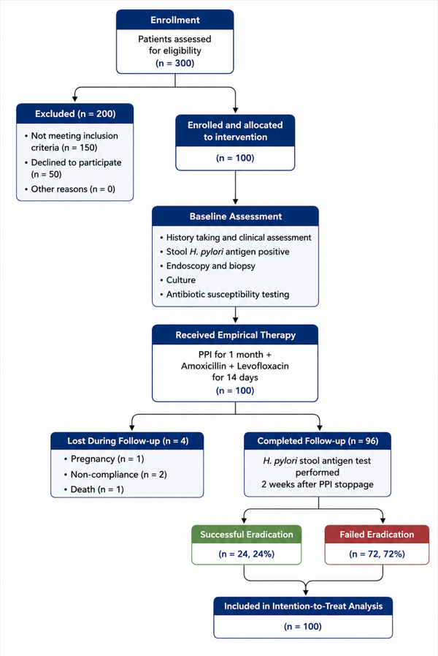
Fig. (1): A study flow diagram of study participants.

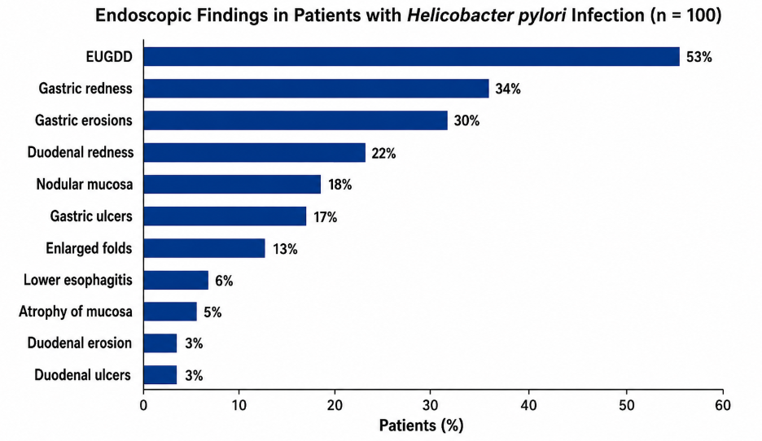

Figure 2. Distribution of endoscopic findings among 100 patients included in the study. Bars represent the percentage of patients presenting each endoscopic abnormality. Multiple lesions could be present in the same patient; therefore, percentages do not total 100%. EUGDD = erosive and ulcerative gastroduodenal disease.

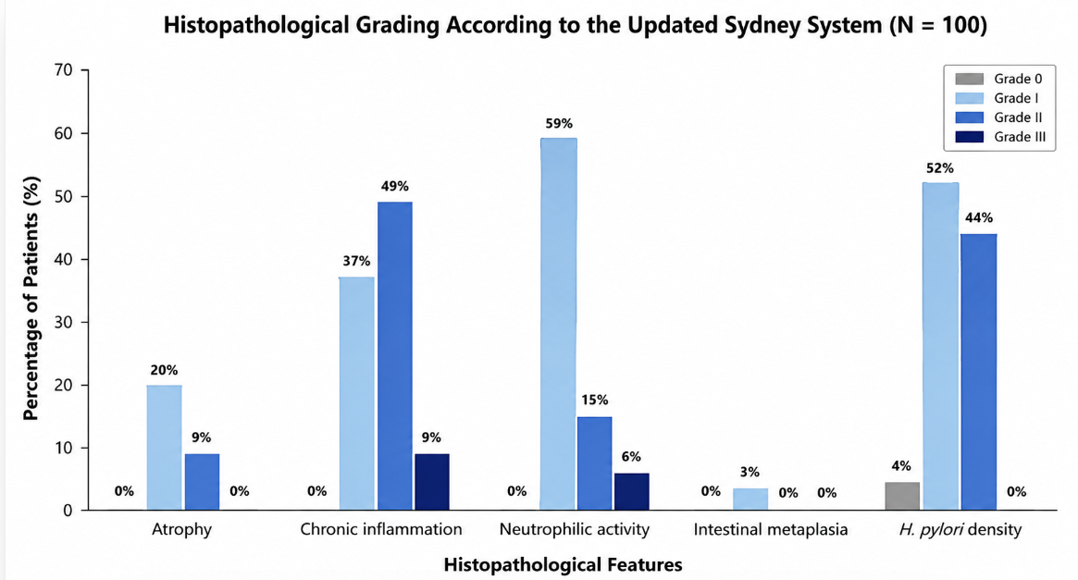
Figure 3. Distribution of histopathological findings according to the Updated Sydney System in the study population (n = 100). Bars represent the percentage of patients within each histological grade (Grades 0–III) for glandular atrophy, chronic inflammation, neutrophilic activity, intestinal metaplasia, and H. pylori density.

